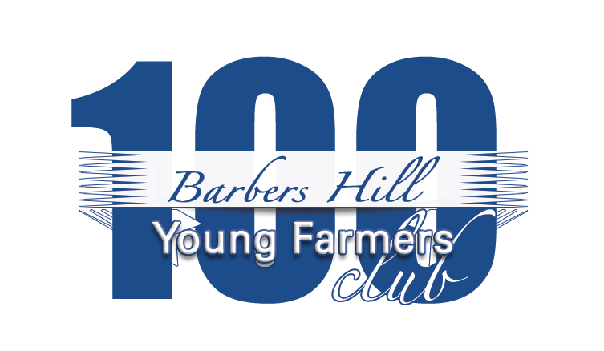
Barbers Hill Young Farmers
PO Box 231
Mont Belvieu, Texas 77580

2015 MEMBERSHIP INFORMATION
The Barbers Hill FFA Sales Committee and Young Farmers would like to invite you to become a member of the 2015 “100 Club”.
The purpose of the club is to allow area businesses and residents to participate in the CHAMBERS COUNTY YOUTH PROJECT SHOW auction. “100 Club” members donate $100 toward the purchase of livestock in the Youth Project Show sale. After the animals have been purchased (cattle, hogs, lambs, goats, rabbits, turkeys and broilers), a drawing will be held among the “100 Club” members for these animals. All “100 Club” members receive a special cap or bag and will be recognized on the show grounds with a poster listing all members.
Our objective is two-fold: 1) to reward students for their hard work, and 2) to keep sale prices at a level at which the students will make a profit for future livestock projects or college savings. The Sales Committee’s goal is to reach buyers who may not be able to attend the auction but who are still interested in supporting our Barbers Hill students.
This year’s show will be held April 29 – May 3, 2015 at White’s Park in Anahuac. Over the past 59 years, thousands of Barbers Hill youngsters have benefited from the exhibition of livestock. Many leaders in our community participated in 4-H and FFA and learned first-hand the value of these programs. We must remain committed to maintaining these programs in order to ensure continued success in training productive citizens for the future.
The 2014 Youth Project Show Auction was a great success because of local businesses and individuals, such as yourself, who are dedicated to our youth in giving your time, consideration, and resources. We raised over $7,000 which allowed our organization to purchase more than 30 animals in the auction and also from students who did not make the auction. The “100 Club” will make every effort to compensate Barbers Hill students for their hard work and dedication.
The Barbers Hill FFA Sales Committee would like to extend a special thank you if you were a member last year and thank you for your consideration and support in joining our “100 Club” membership roster for 2015. By supporting the youth of Barbers Hill, you are investing in their future.

Ralph W. Wilson
BHHS Agriculture Science Teacher
Barbers Hill “100 Club” Advisor
Supporting Barbers Hill Youth Since 1994

