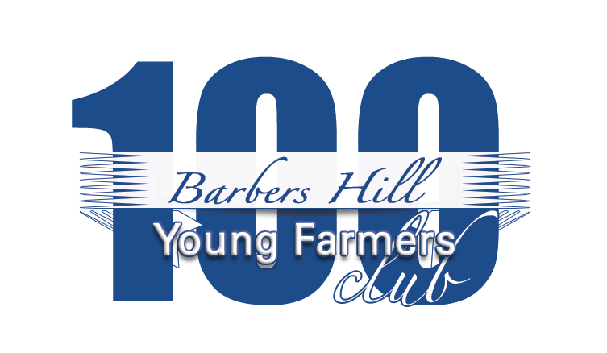

Supporting Barbers Hill Youth Since 1994

GOALS:
- To maintain minimum prices on Barbers Hill youth livestock sold in the premium sale at the Chambers County Youth Project Show.

- To provide potential contributors with an easily accessible buyer’s group.

GUIDELINES:
- Donations will be $100 per membership per year.

- Each paid membership entitles a member one chance in the drawing for animals purchased in the sale.

- All animals purchased in the sale by the “100 Club” will be drawn in the following order:
1) Market Steers 5) Market Goats
2) F-1 Heifers 6) Market Broilers
3) Market Hogs 7) Market Lambs
4) Market Rabbits 8) Market Turkeys

- Each member will receive a Barbers Hill “100 Club” cap or bag.

- Each member will complete the attached form and designate what they wish to do with the animal in the event their name is drawn.

- If a winner does not wish to receive an animal they win, the drawing will continue until the name of someone who wishes to receive the animal is drawn.

- The winners will handle animals that are to be resold.

- Please make checks payable to Barbers Hill Young Farmers and send to Barbers Hill Young Farmers P.O. Box 231; Mont Belvieu, TX 77580 by April 24, 2015.
A “100 Club” committee member will contact you to deliver your bag or cap.

Thank You for Your Support!

